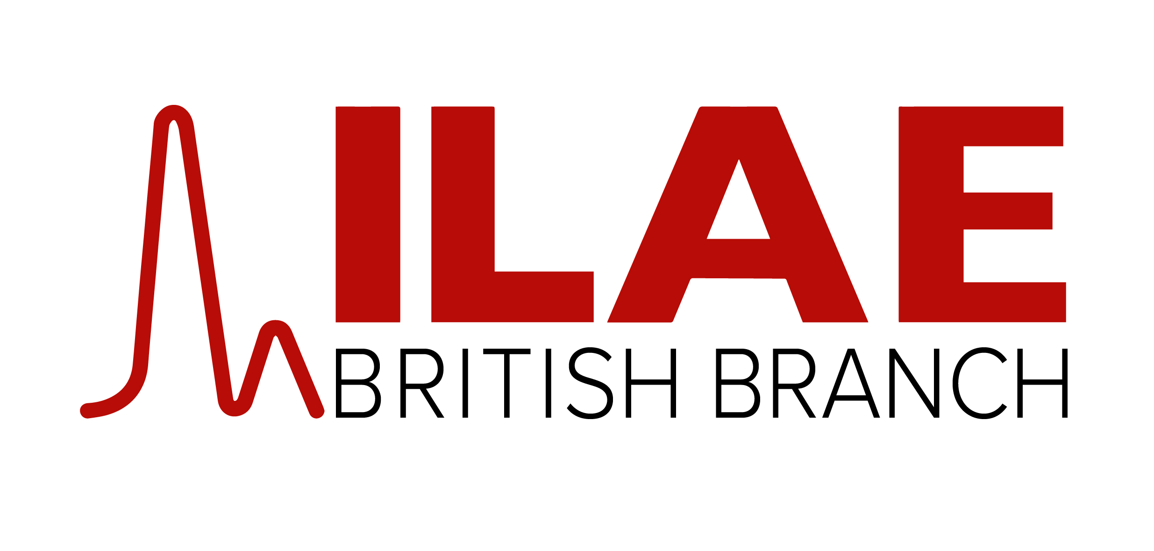
CRITERIA GUIDANCE FOR BURSARY APPLICATIONS CAN BE FOUND ON OUR WEBSITE
WWW.ILAEBRITISH.ORG.UK

Please email your application along with the supporting documentation to members@ilaebritish.org.uk
or send to ILAE British Branch, PO Box 70977, London, SE25 9EA.

BURSARY APPLICATION FORM

Name:

Email address:

Current appointment:

Name and location of course:

(Please ensure that you attach details of the course with this application – letter of invitation/course programme).

Dates of course:

Where else have you applied for funding?

Have you been successful in securing funding from elsewhere? Yes/No (please circle)
If yes, how much have you been awarded? Please specify the amount

Expenses required:

Course fee:
(please attach confirmation of amount from the course organisers)

Total claim:

Signature of applicant: ………………………
(A scanned signature is acceptable)

Date:

